### **EC2 Instance:**

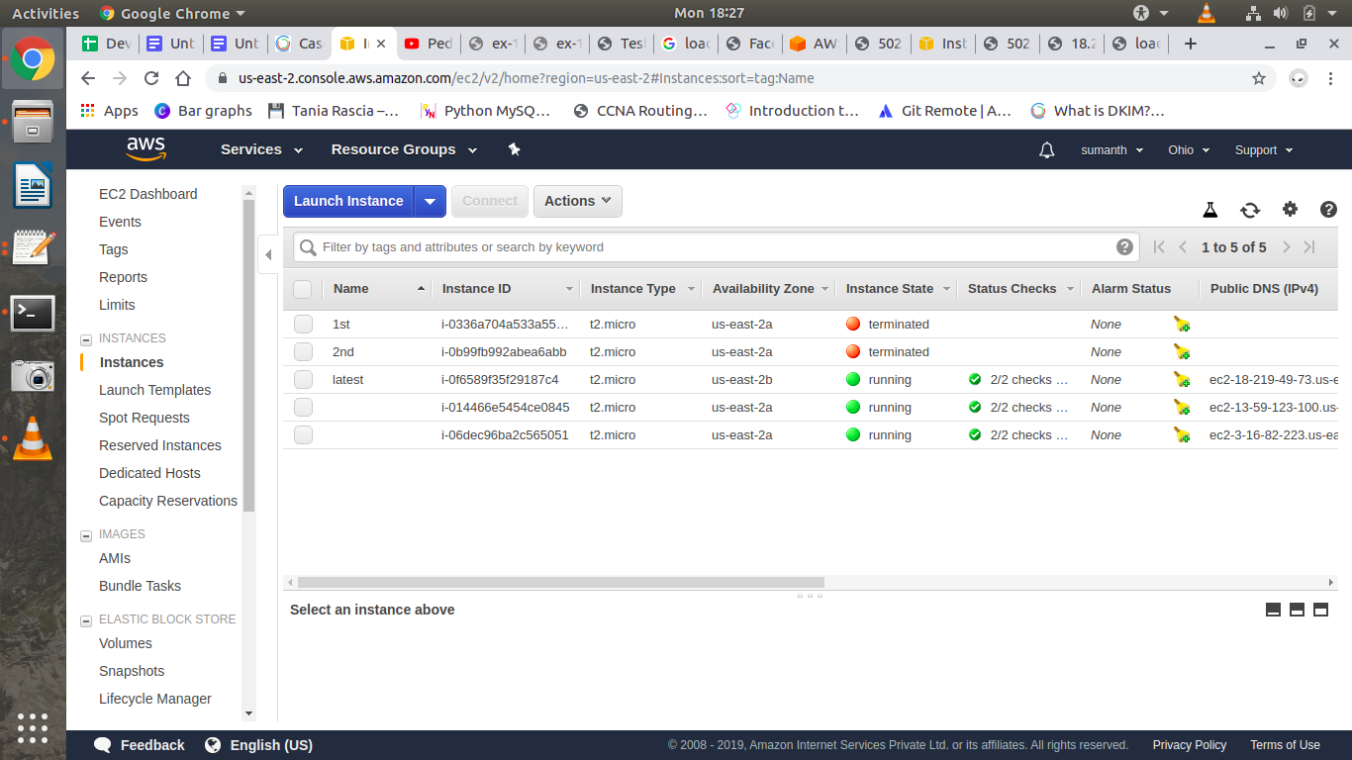

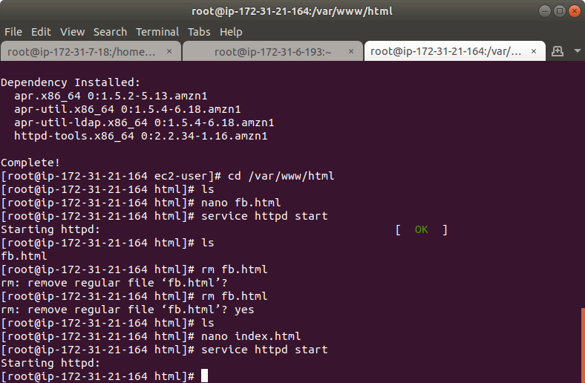

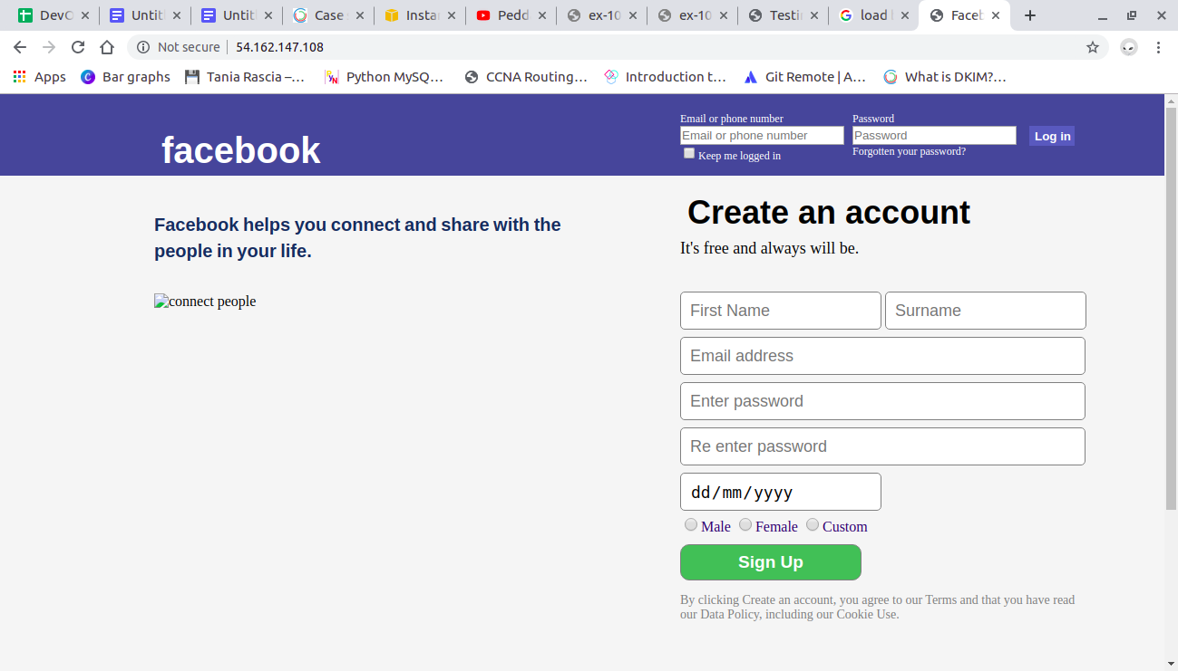

### 

### 

### **Load Balancer:**

Application load balancer:

It provides advanced routing features such as host-based and path-based routing

Host based routing:

Suppose you have two websites. Each website is hosted on two EC2 instances you want to distribute the incoming web traffic between them. If you were using the CLB you would have to create two load balancers, one for each website. But you can do the same thing using a single ALB.

Path-based Routing:

Suppose the website of your company is <http://my-load-balancer-636861390.us-east-2.elb.amazonaws.com/> nd the company’s blog is hosted on <http://my-load-balancer-636861390.us-east-2.elb.amazonaws.com/blog> . Using ALB you can route traffic based on the path of the requested URL.

1. First create two instances named Main and Blog.

2. Install Apache server on instances

In both the servers keep the html file name same as index.html

3. Create Target Groups

In the left navigation bar, scroll down and click on Target Groups.

Now click on Create target group at the top.

Give your target group name and click create button.

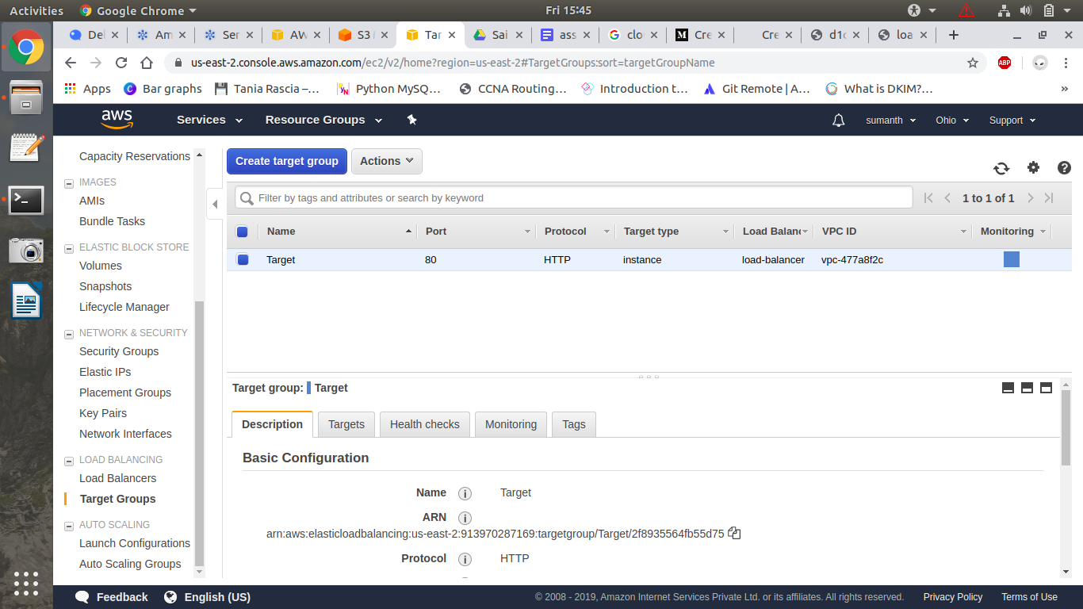

Now, navigate to the Targets tab at the bottom, click on Edit, select both instances, click Add to registered and click Save.

4. Creating and configuring the Application Load Balancer

Choose the Application Load Balancer.

Give a name to your load balancer click on the Next: Configure Security Settings button.

Create new security group with ssh, http, https

Click Next again, review and click Create.

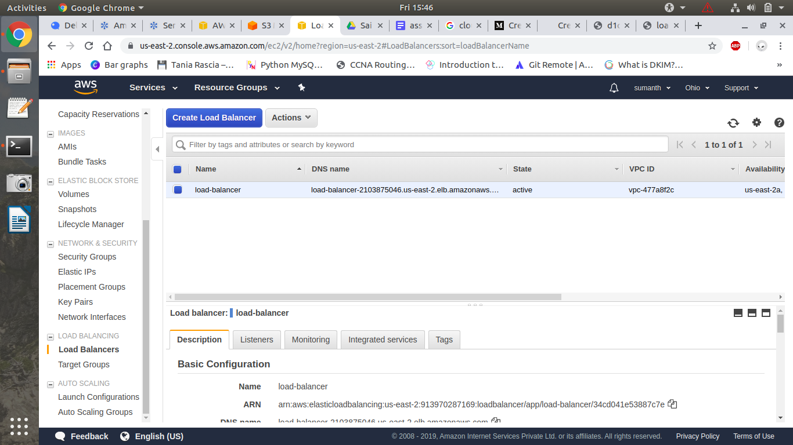

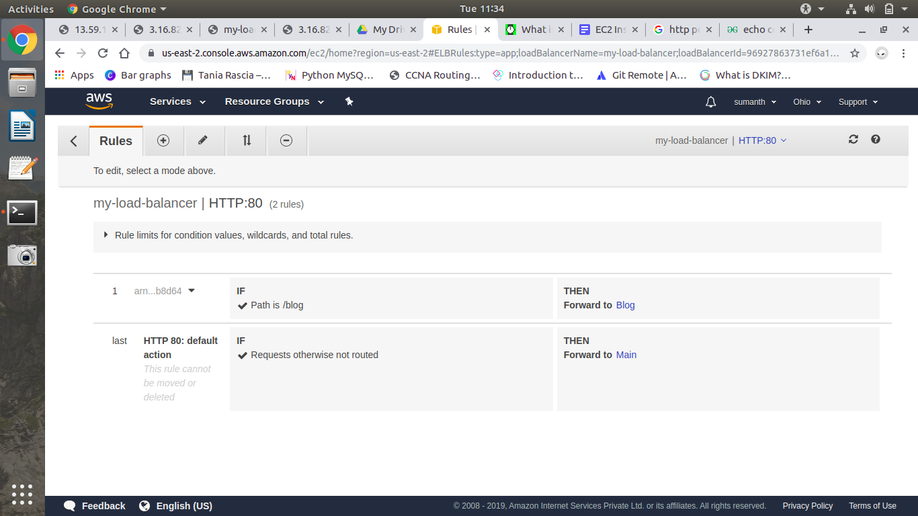

Now, we can use the DNS name of our load balancer to visit the two different paths and

see the results.

Wait for some time until the load balancer become active.

Copy the dns name of load balancer and search it in browser.

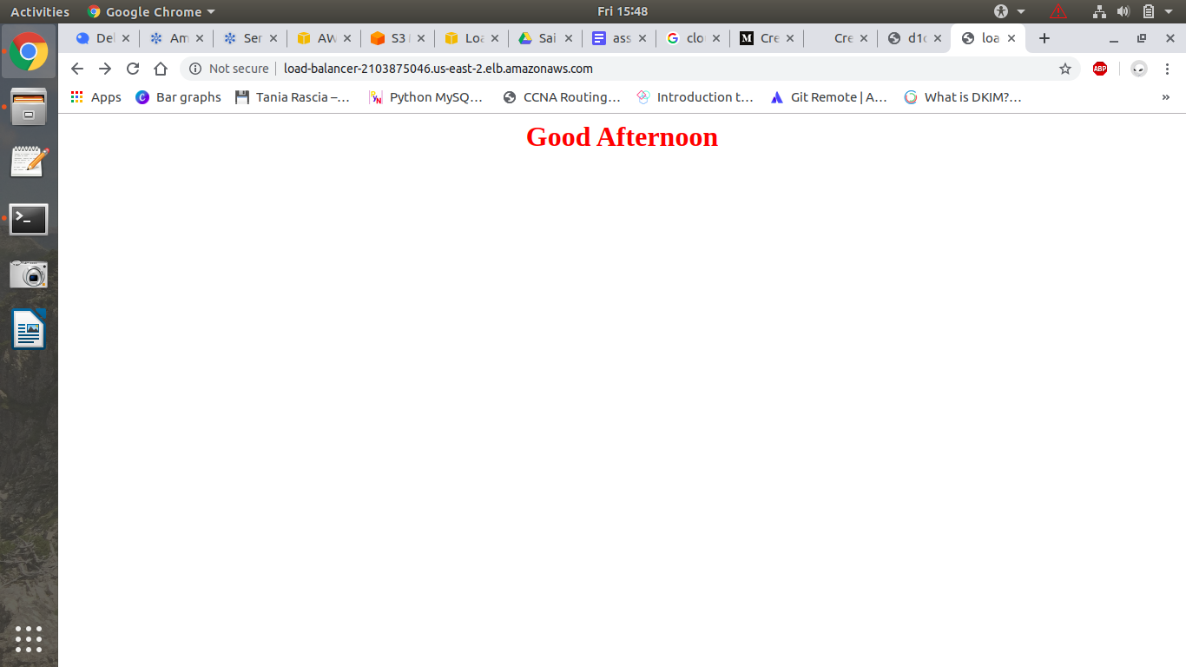

Click Refresh and the second server content will be displayed. 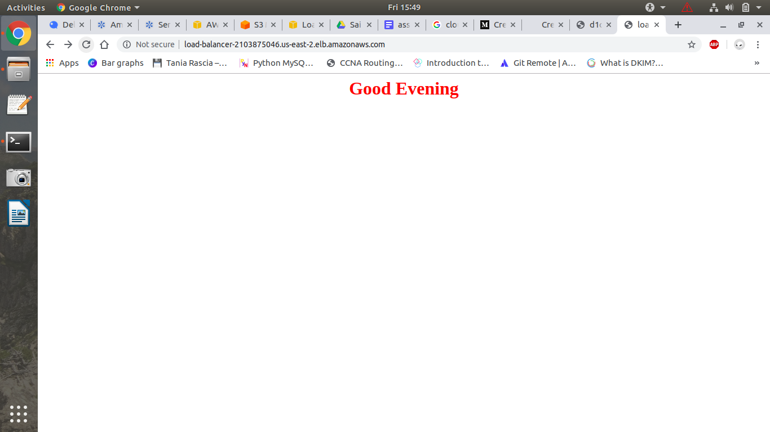

What happened here is load balancer follows round robin and forward one request to one server and another request to another server therefore balancing the load.

Here we have taken the file name same but different content in the file to show the difference that request is going to another server.

### 

### **Auto Scaling:**

Here i have created two instances using auto scaling and applied stress on two instances and another instance created automatically

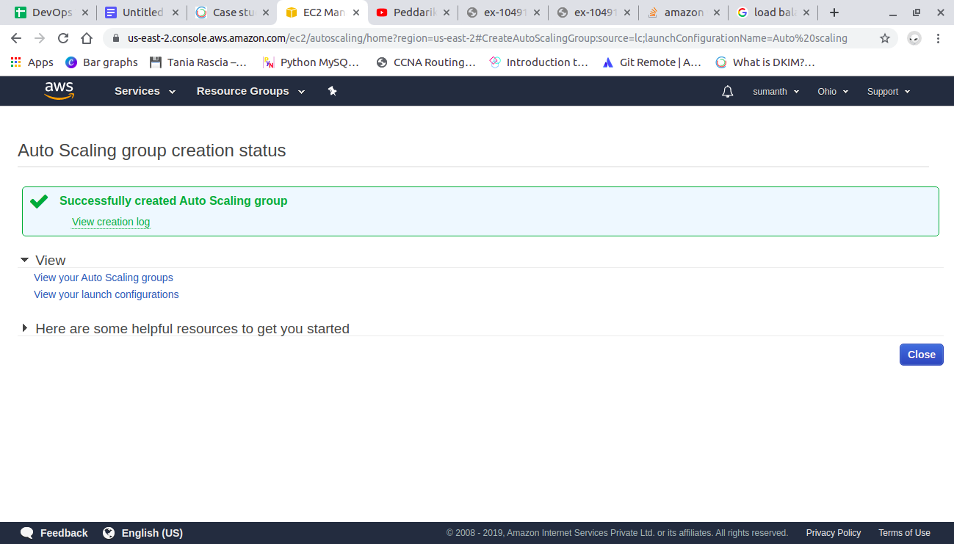

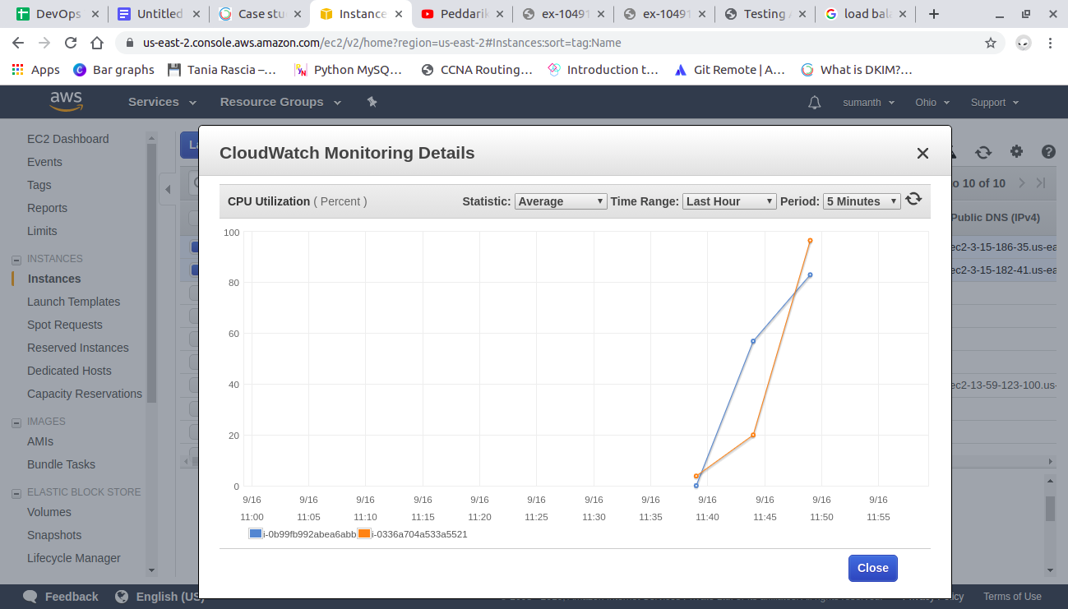

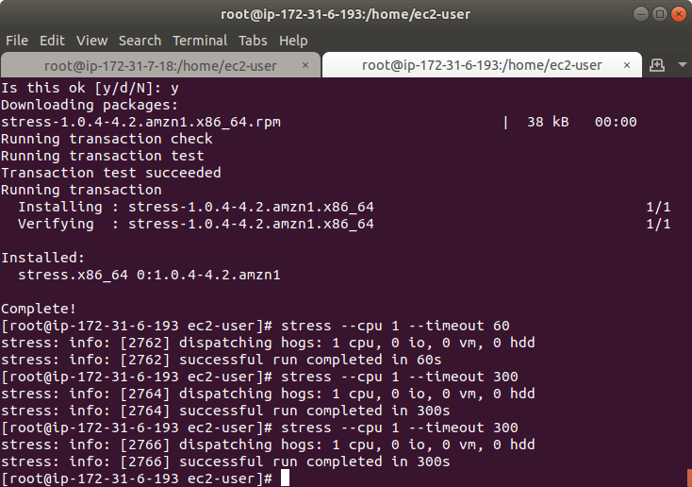

After removing the stress first two instances terminated:

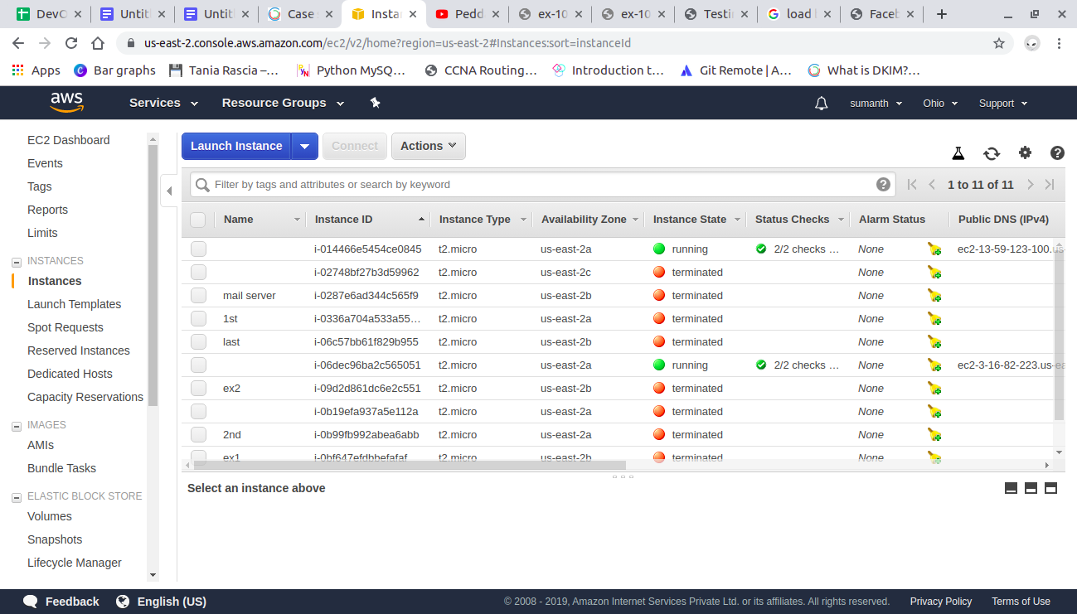

### 

### **IAM:**

Identity Access Management

I have created four users and assigned them to a group called Devops and I have given on s3-readonly-access permission.

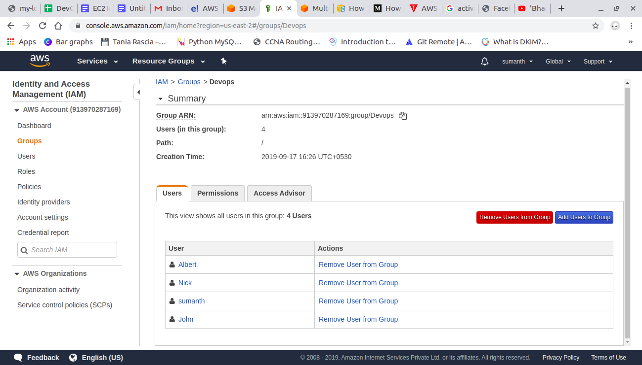

And I have tried to open ec2 instance which is not given in the users permission and it restricted my access.

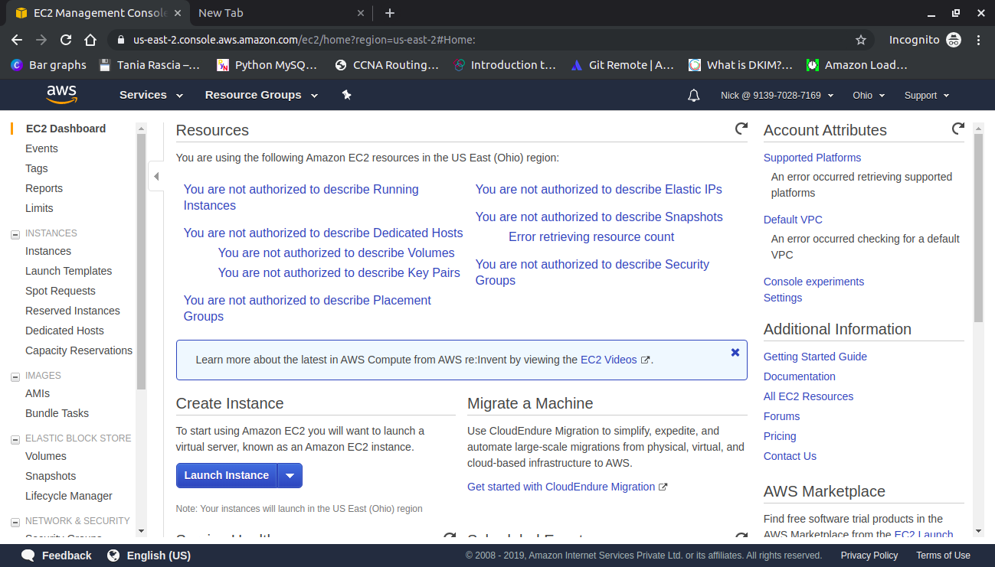

S3 Bucket:

I have created a bucket in s3 and changed the properties to static web hosting.

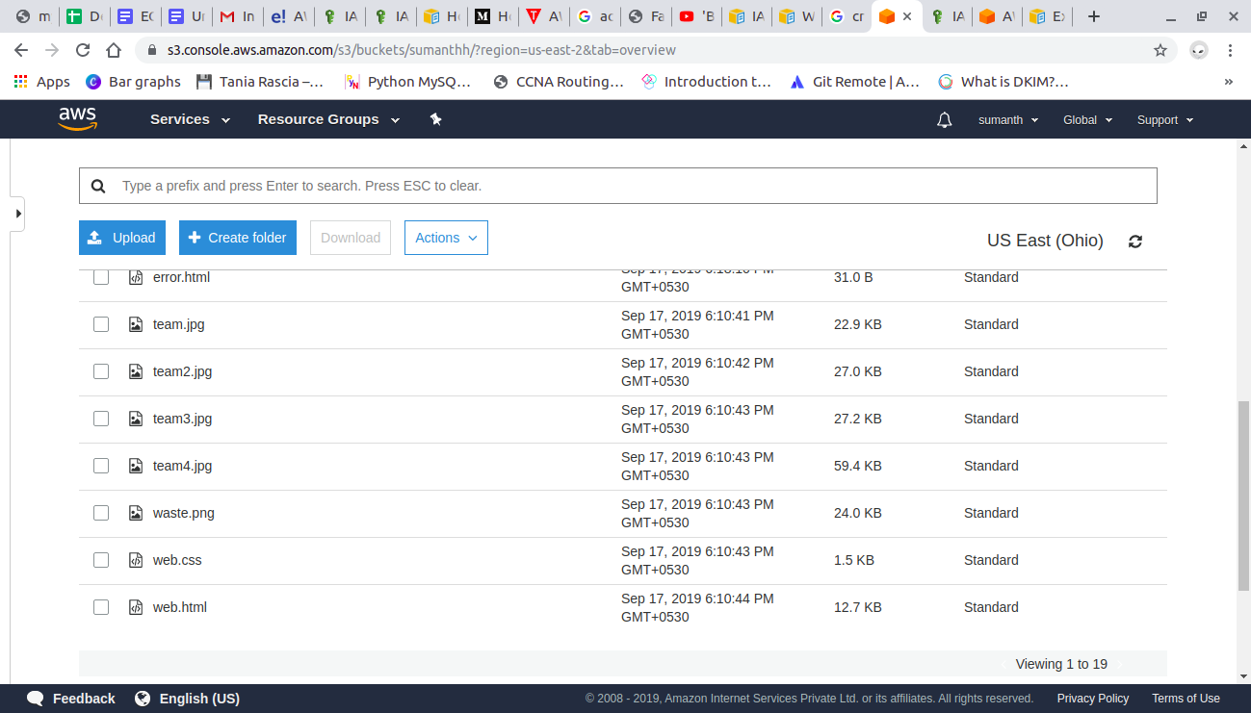

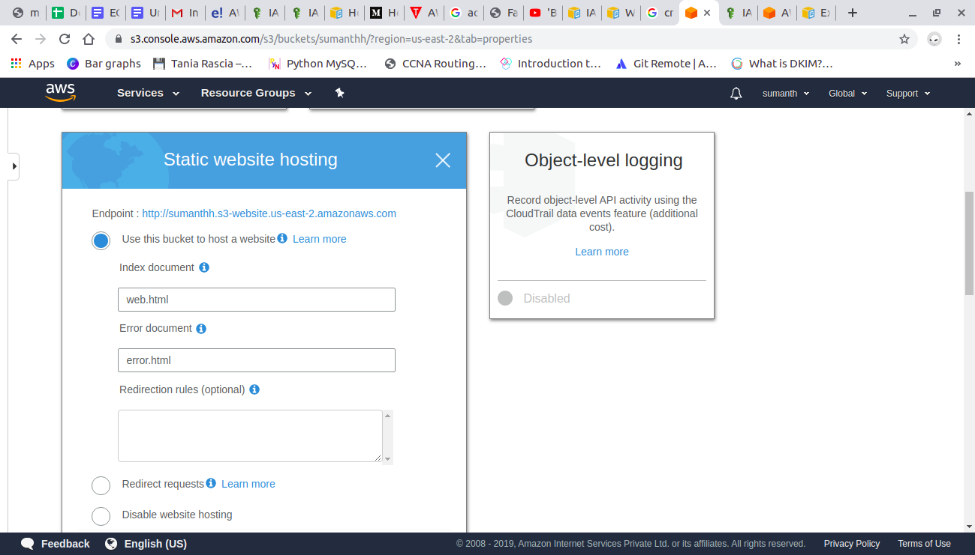



### **Replication:**

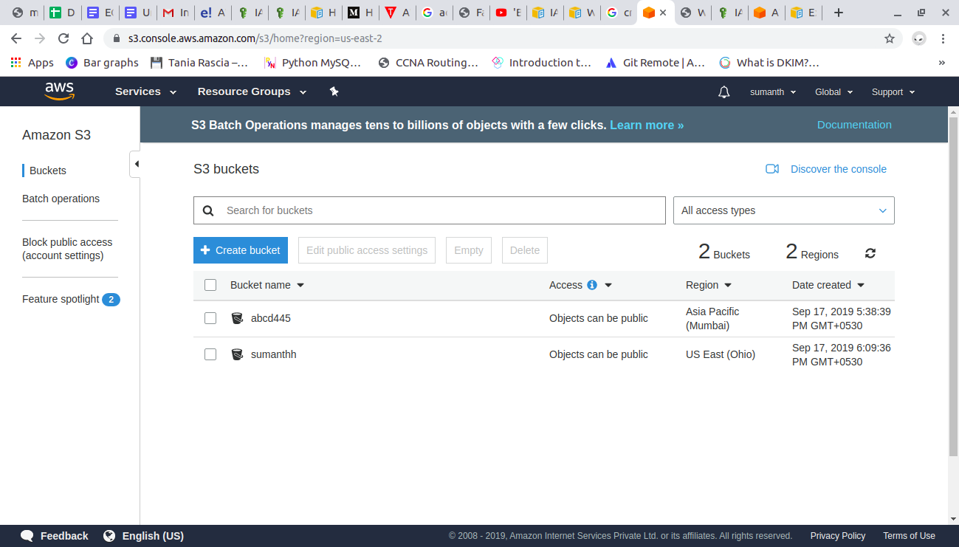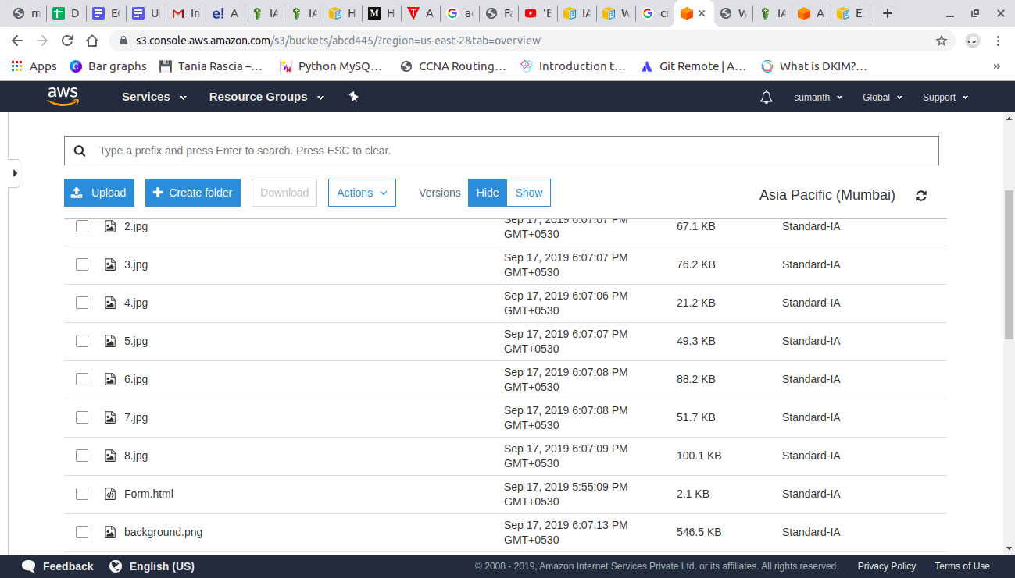

### **Cloud Watch:**

I have created a cloud watch alarm for CPU utilization which sends you an alarm email when CPU utilization reaches beyond threshold value which I took as 80%

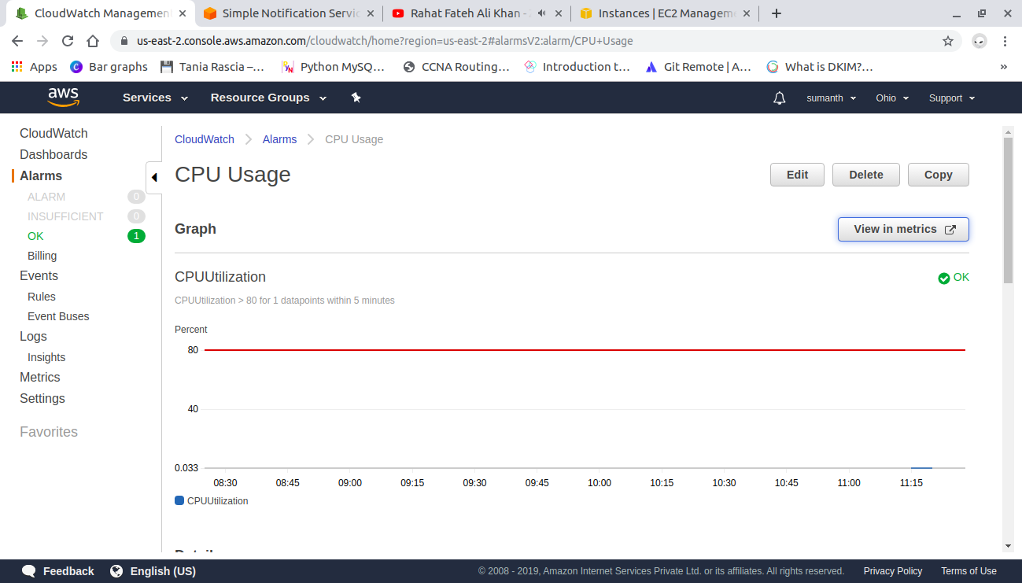

I increased the stress on CPU using stress command and CPU utilization exceeded threshold value

sudo su

Yum install stress

stress --cpu 8 --timeout 300

After it exceeded threshold value using sns it sent a mail

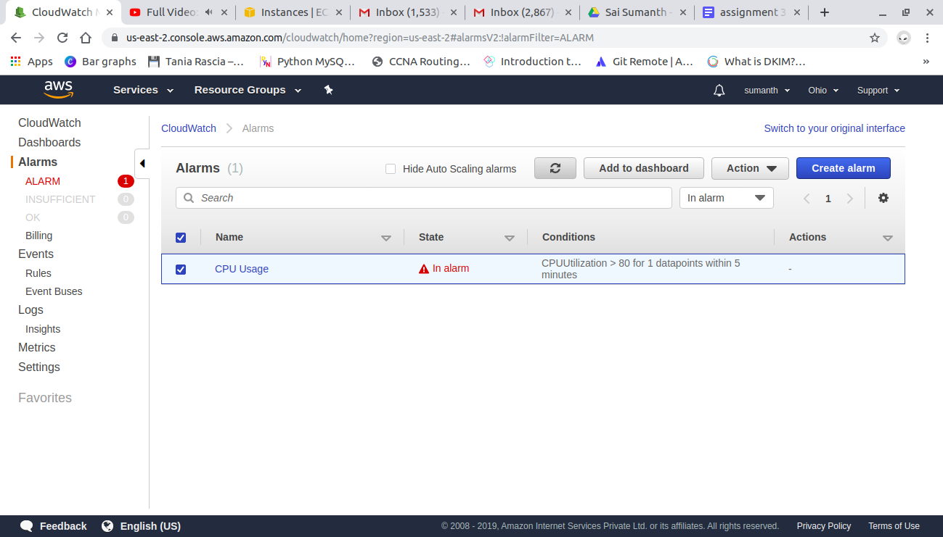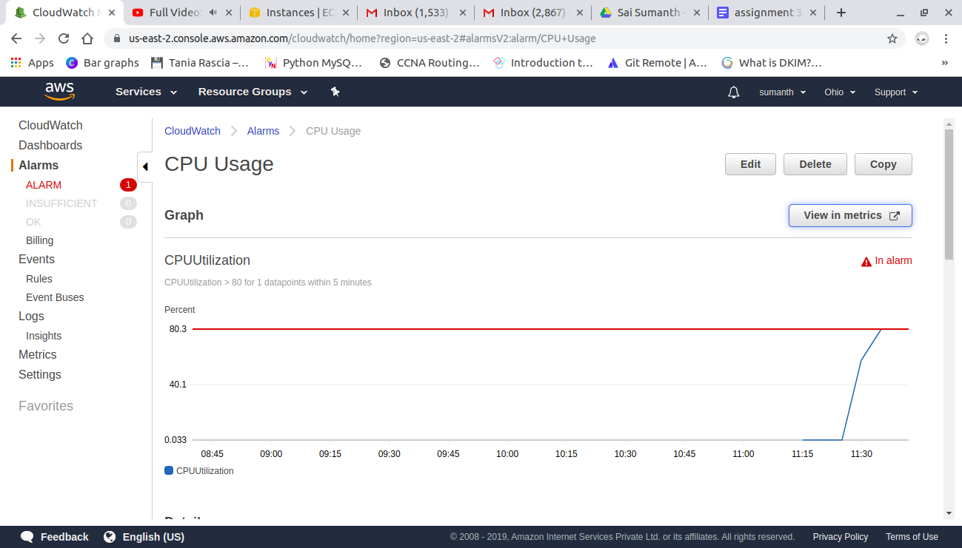

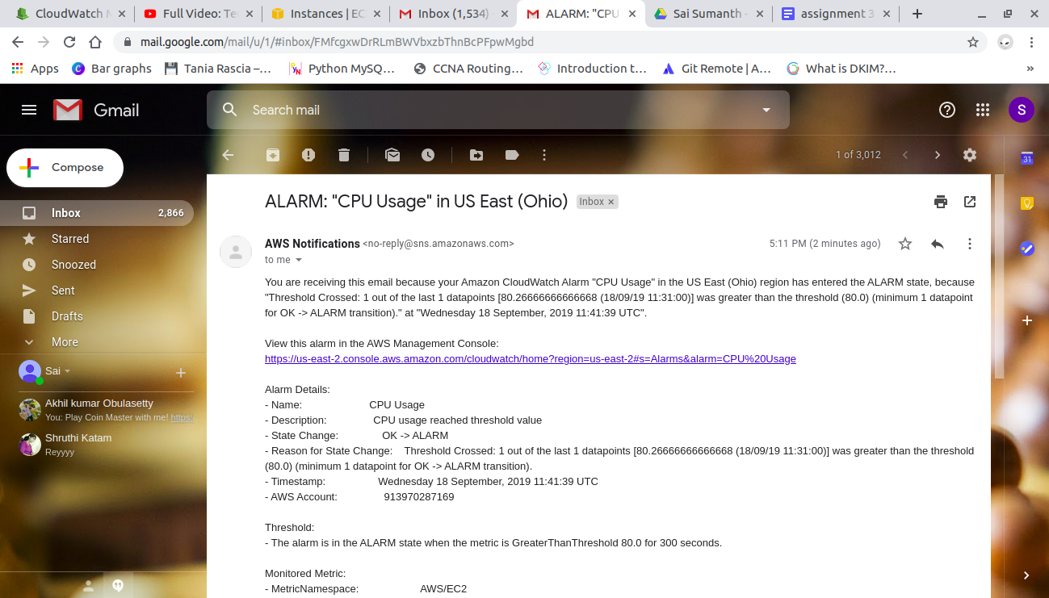

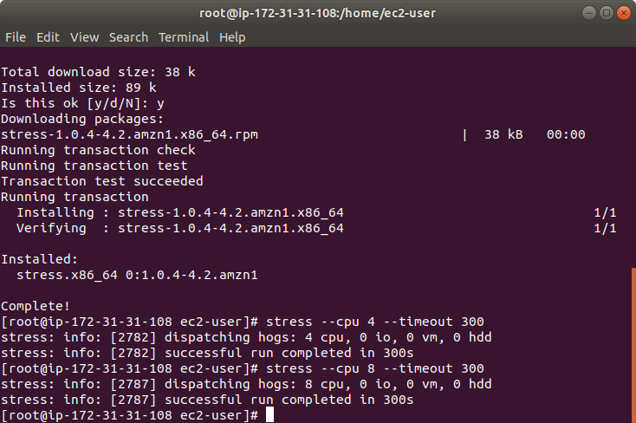

### **Apache Server:**

I have created a .conf file which named hello.conf

<VirtualHost *:80>

ServerName 18.189.13.5

ServerAdmin webmaster@localhost

DocumentRoot /var/www/html/training

</VirtualHost>

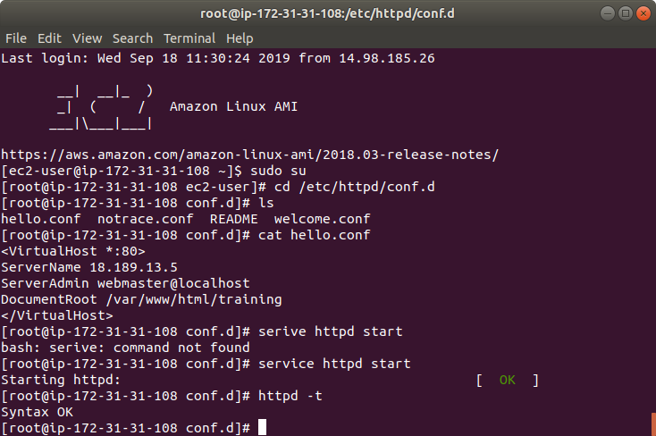

We have configured config file such that if we enter the ip address the html file opens

I have entered the ip address in the browser and web page loaded.

If a directory is requested (i.e. a path ending with /), the file served from that directory is defined by the DirectoryIndex directive.

We can access the file fb.html file which is in /var/www/html/fb by typing /fb after the ip address if we write the following config file.

*<VirtualHost *:80>*

*ServerName 18.223.131.97*

*ServerAdmin webmaster@localhost*

*DocumentRoot /var/www/html*

*<Location /fb>*

*DirectoryIndex fb.html*

*</Location>*

*</VirtualHost>*

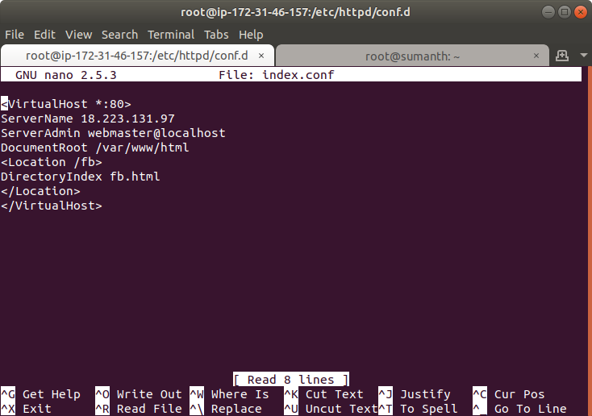

Here I accessed the fb.html file just by typing /fb after ip address.

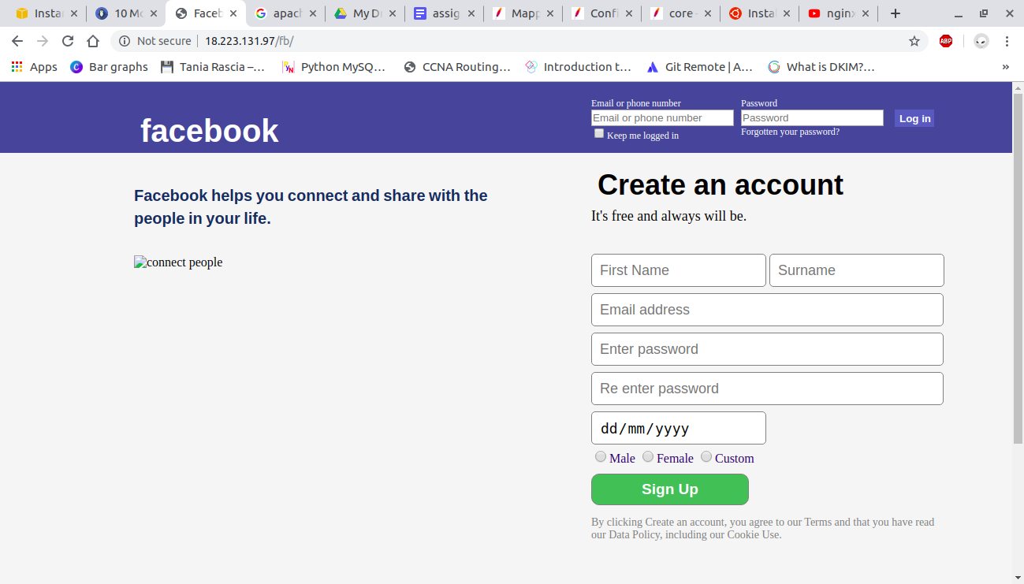

### **AMI Creation:**

Go to instances and select the instance you want to create AMI for

Click on Actions and select image and create AMI

Snapshot will be created automatically when AMI is created.

Launch the AMI and open it in terminal

Do not install httpd service in AMI because it is already created in the instance which we took backup

Start httpd service and copy the ip address of launched AMI and paste it.

The website should open automatically.

AMI created:

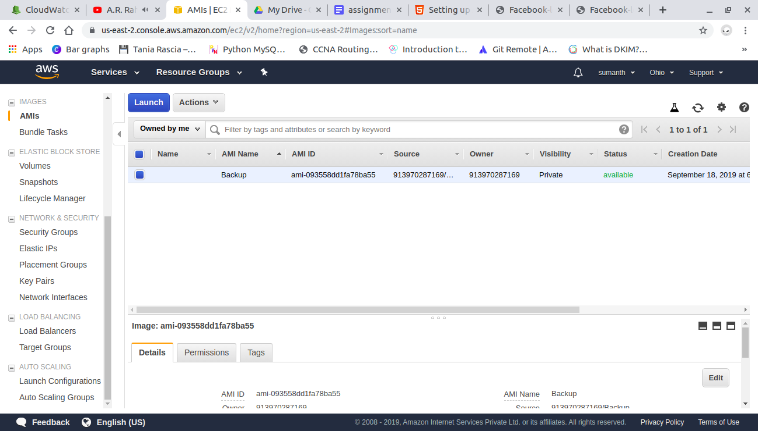

Launch newly created instance on terminal and do not install httpd

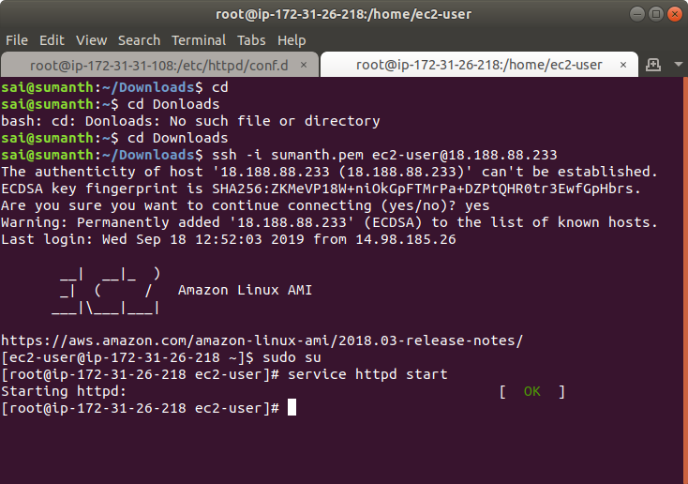

Copy the ip address of newly created instance in browser and website should open automatically

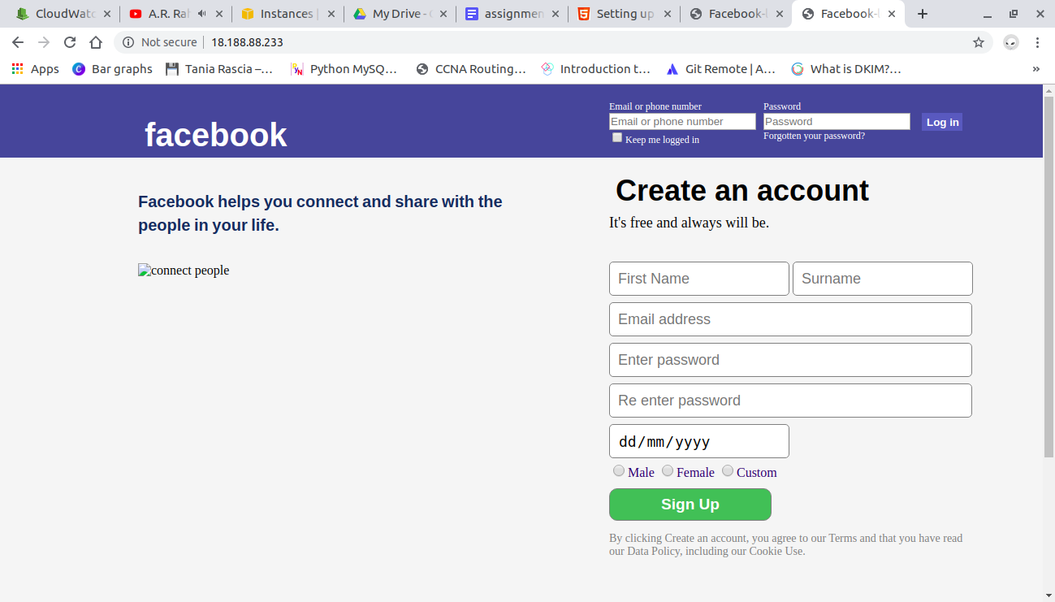

### **Nginx server:**

Install the nginx server using

yum install nginx;

Go to /etc/nginx/conf.d

And create a new configuration file using the folllowing commands.

*server{*

*listen 80;*

*server_name 18.223.131.97;*

*root /var/www/html;*

*index index.html;*

*error_log /var/log/nginx/error.log;*

*location /fb*

*{*

*root /var/www/html/;*

*index fb.html;*

*}*

*}*

Here I created a folder named fb in /var/www/html and a file named fb.html

If I type /fb after the ip address fb.html page should open.

The location /var/www/html will be there in httpd so if you want to use that location first we have to install httpd service.

Nginx service :

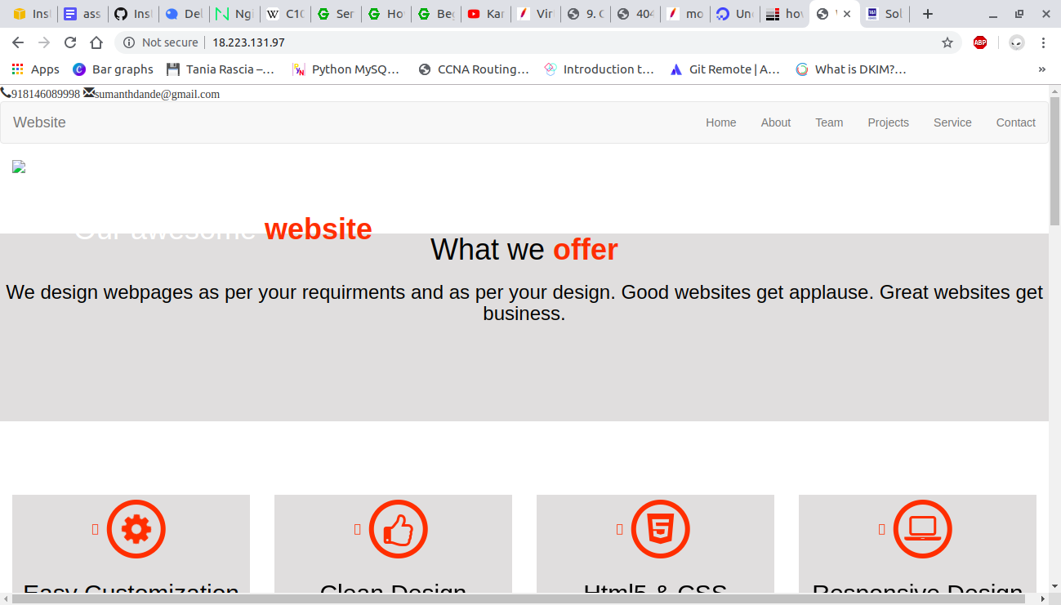

Nginx configuration file

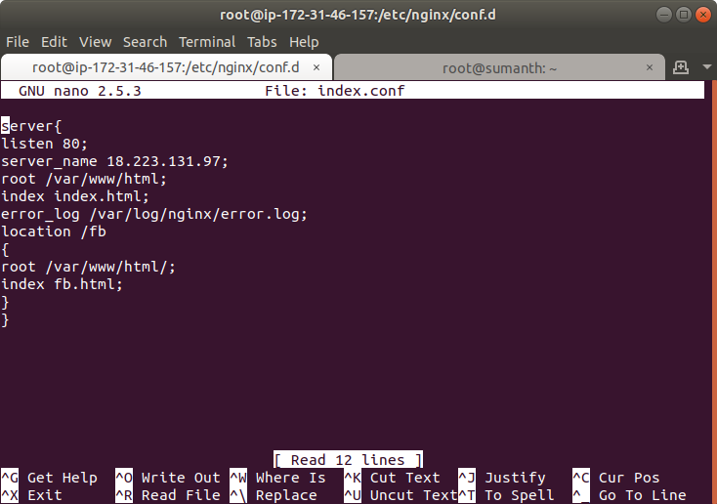

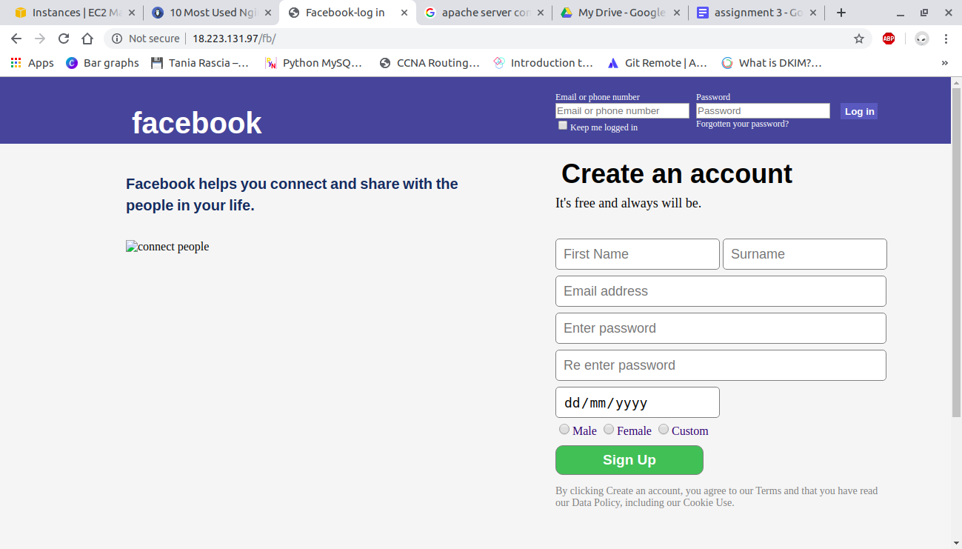

## **CloudFormation:**

### **Creating Template for CloudFormation:**

*AWSTemplateFormatVersion: 2010-09-09*

*Description: >-*

*AWS CloudFormation Sample Template EC2InstanceWithSecurityGroupSample: Create*

*an Amazon EC2 instance running the Amazon Linux AMI. The AMI is chosen based*

*on the region in which the stack is run. This example creates an EC2 security*

*group for the instance to give you SSH access.*

*Parameters:*

*KeyName:*

*Description: Name of an existing EC2 KeyPair to enable SSH access to the instance*

*Type: 'AWS::EC2::KeyPair::KeyName'*

*ConstraintDescription: must be the name of an existing EC2 KeyPair.*

*InstanceType:*

*Description: WebServer EC2 instance type*

*Type: String*

*Default: t2.micro*

*ConstraintDescription: must be a valid EC2 instance type.*

*AllowedValues:*

*- t2.micro*

*- t2.large*

*- t2.medium*

*SSHLocation:*

*Description: The IP address range that can be used to SSH to the EC2 instances*

*Type: String*

*MinLength: '9'*

*MaxLength: '18'*

*Default: 0.0.0.0/0*

*AllowedPattern: '(\d{1,3})\.(\d{1,3})\.(\d{1,3})\.(\d{1,3})/(\d{1,2})'*

*ConstraintDescription: must be a valid IP CIDR range of the form x.x.x.x/x.*

*VPCIdName:*

*Description: Select the VPICId name*

*Type: 'AWS::EC2::VPC::Id'*

*SubnetID:*

*Description: SubnetID*

*Type: 'AWS::EC2::Subnet::Id'*

*Mappings:*

*RegionMap:*

*us-east-2:*

*AMI : ami-0c64dd618a49aeee8*

*us-east-2:*

*AMI : ami-00c03f7f7f2ec15c3*

*ap-northeast-1:*

*AMI : ami-0c64dd618a49aeee8*

*ap-northeast-1:*

*AMI : ami-00c03f7f7f2ec15c3*

*Resources:*

*EC2Instance:*

*Type: 'AWS::EC2::Instance'*

*Properties:*

*InstanceType: !Ref InstanceType*

*SecurityGroups:*

*- !Ref InstanceSecurityGroup*

*KeyName: !Ref KeyName*

*ImageId: !FindInMap*

*- RegionMap*

*- !Ref AWS::Region*

*- AMI*

*UserData:*

*Fn::Base64:*

*!Sub |*

*#!/bin/bash -xe*

*yum install -y git*

*yum install -y httpd*

*cd /var/www/html*

*git clone https://gitlab.com/Sumanthh/cloudformation.git*

*cd cloudformation*

*mkdir local*

*cd local*

*touch website.html*

*echo "This is a sub folder file" >> website.html*

*cd /etc/httpd/conf.d*

*touch index.conf*

*echo "<VirtualHost *:80>*

*ServerName*

*ServerAdmin webmaster@localhost*

*DocumentRoot /var/www/html/cloudformation*

*<Location /sub>*

*DirectoryIndex website.html*

*</Location>*

*</VirtualHost> " >> index.conf*

*InstanceSecurityGroup:*

*Type: 'AWS::EC2::SecurityGroup'*

*Properties:*

*GroupDescription: Enable SSH access via port 22*

*SecurityGroupIngress:*

*- IpProtocol: tcp*

*FromPort: '22'*

*ToPort: '22'*

*CidrIp: 0.0.0.0/0*

*- IpProtocol: tcp*

*FromPort: '80'*

*ToPort: '80'*

*CidrIp: 0.0.0.0/0*

*- IpProtocol: tcp*

*FromPort: '443'*

*ToPort: '443'*

*CidrIp: 0.0.0.0/0*

*Outputs:*

*InstanceId:*

*Description: InstanceId of the newly created EC2 instance*

*Value: !Ref EC2Instance*

*AZ:*

*Description: Availability Zone of the newly created EC2 instance*

*Value: !GetAtt*

*- EC2Instance*

*- AvailabilityZone*

*PublicDNS:*

*Description: Public DNSName of the newly created EC2 instance*

*Value: !GetAtt*

*- EC2Instance*

*- PublicDnsName*

*PublicIP:*

*Description: Public IP address of the newly created EC2 instance*

*Value: !GetAtt*

*- EC2Instance*

*- PublicIp*

Template is created successfully without any errors.

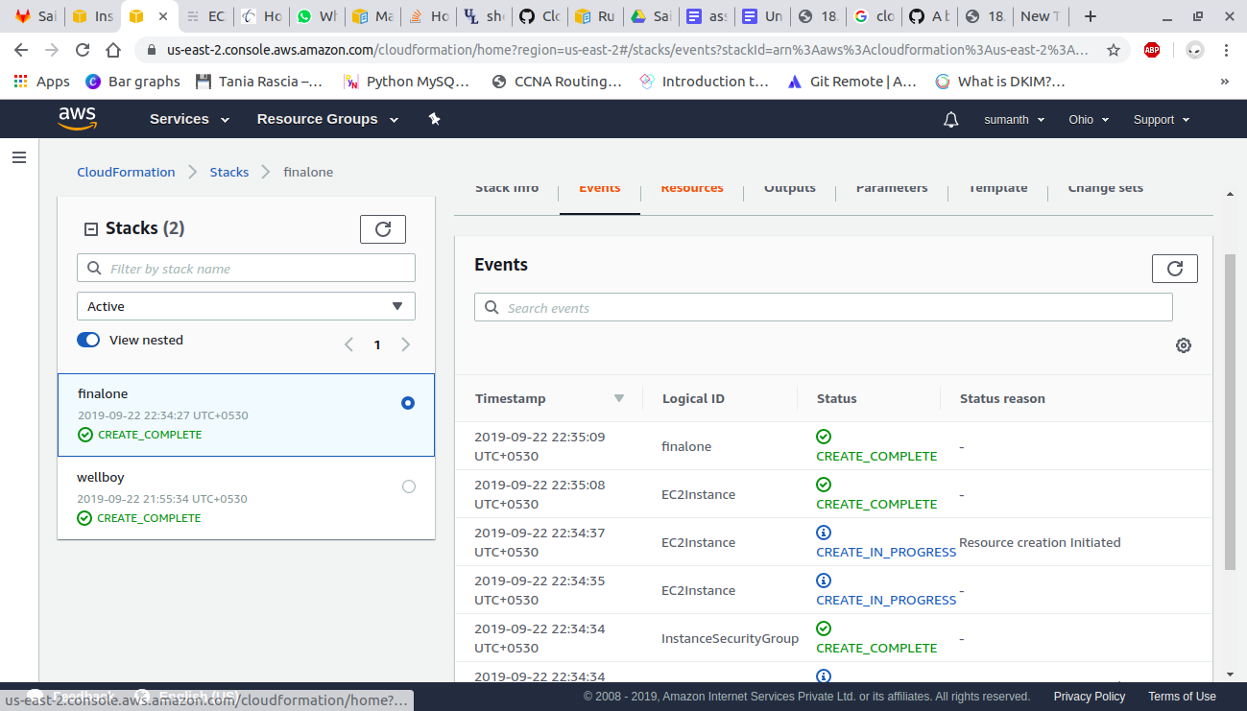



I have created a configuration file in /etc/httpd/conf.d in user data.

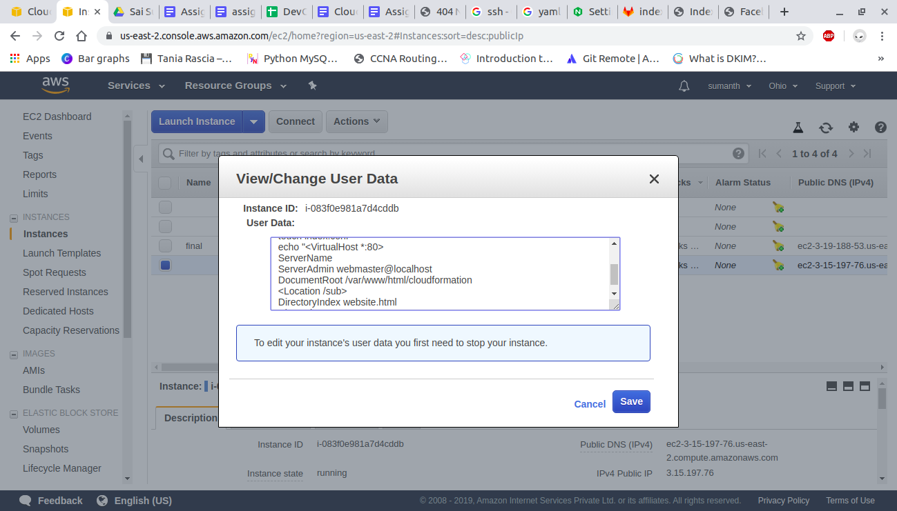

If we enter the ip address of the instance the website will open

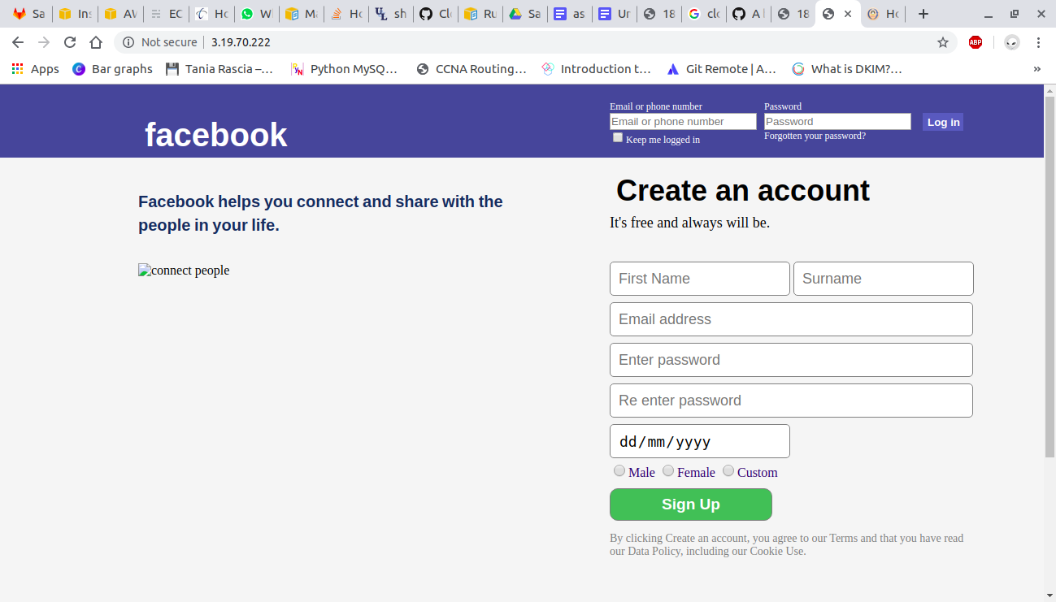

If we add /local to the website another website should open.

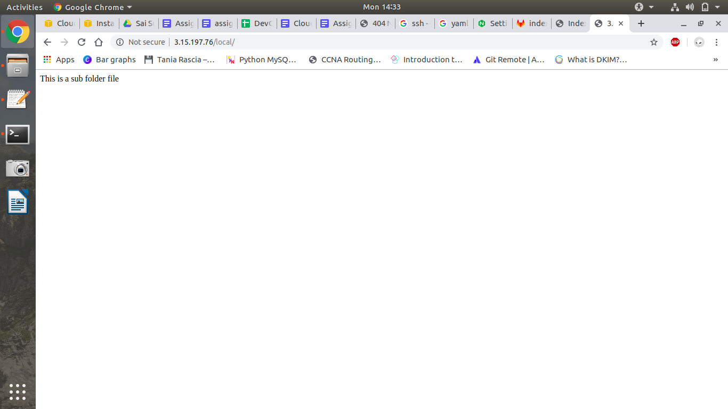

### **VPC:**

I have created a VPC with two subnets one public subnet and one private subnet 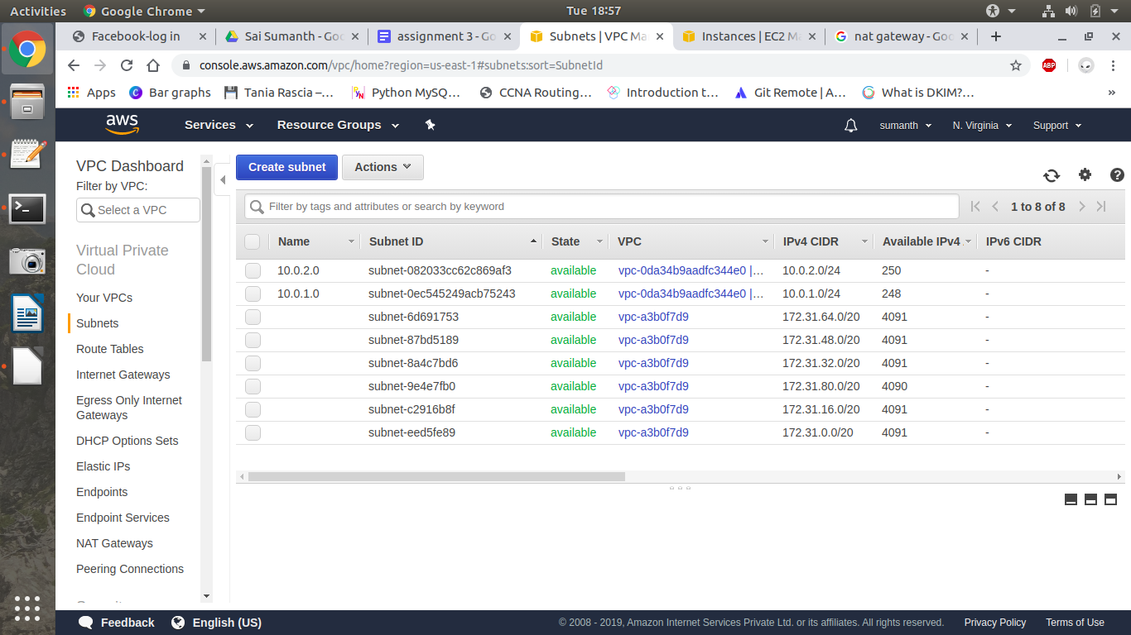

And i have created two route tables for two instances created from subnets and vpc.

For public route table I have added the Internet gateway and for private route table I have added NAT Gateway.

In subnet association in route table add public subnet in public route table and private subnet in private route table.

Public route table routes:

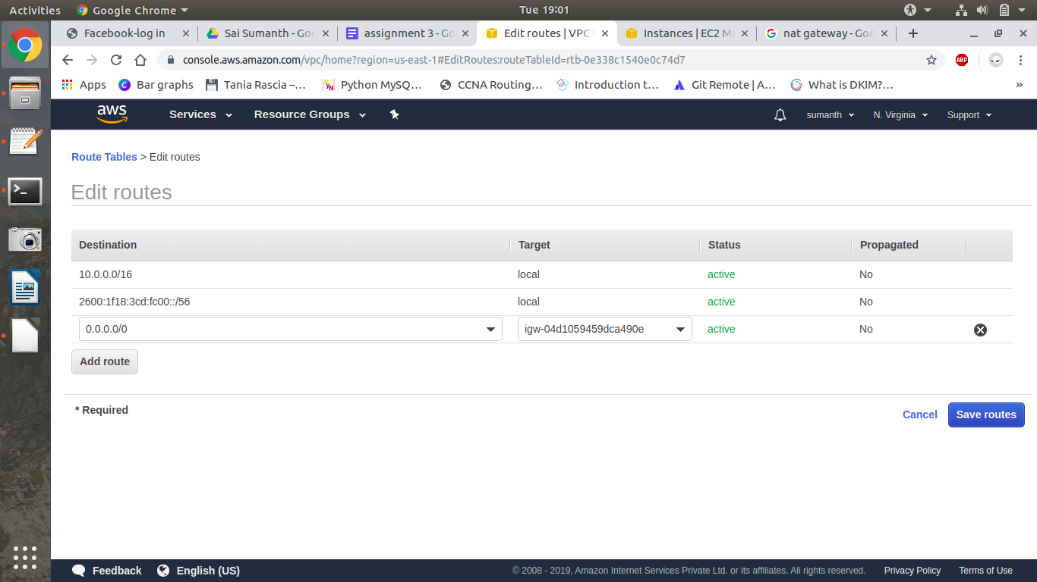

Private route table routes:

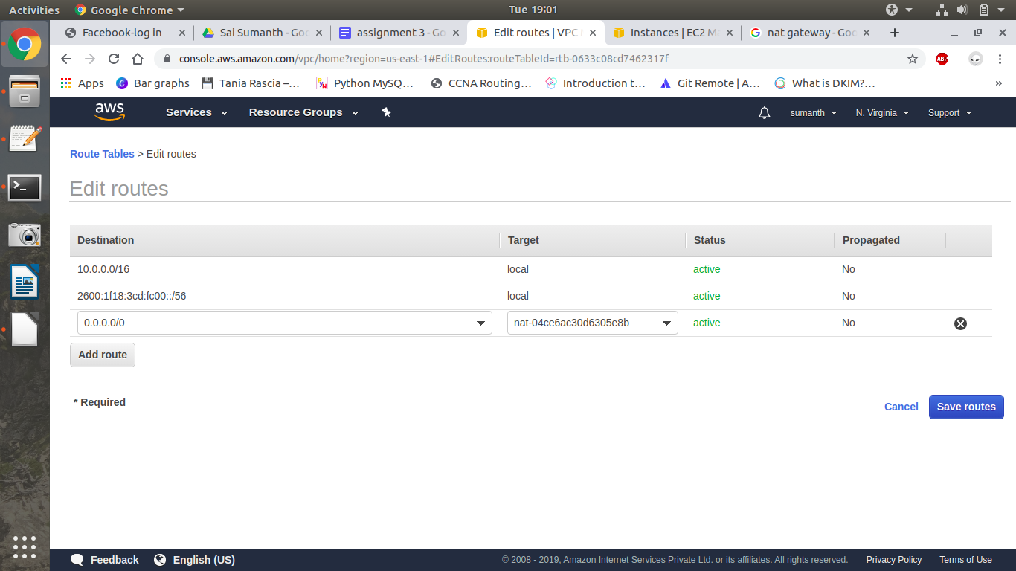

#### **NAT Gateway:**

In NAT Gateway we have to add public subnet because through public subnet we will access internet to private instances.

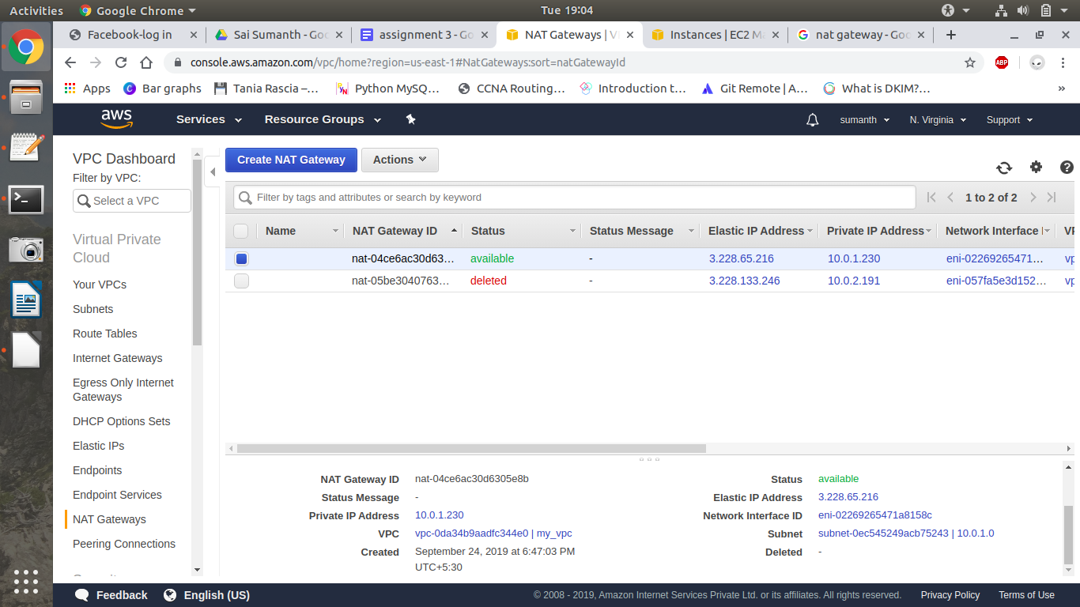

#### **Connecting to a private instance with public instance:**

In private instance edit the security group

Change the source in inbound rules

Instead of 0.0.0.0/0 type the name of the security group of public instance.

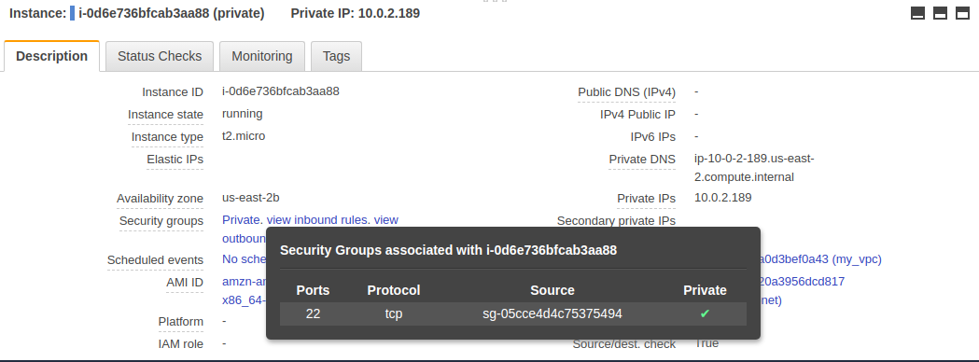

To connect to private instance type the following command:

ssh -o ProxyCommand=’ssh -i <keyfile> -W %h:%p ec2-user@<publicip_address>’ ec2-user@<privateip_address> -i <keyfile>

*ssh -o ProxyCommand='ssh -i kwik.pem -W %h:%p ec2-user@35.176.236.57' ec2-user@172.31.29.72 -i kwik.pem*

To check internet connectivity in private instance install any service.

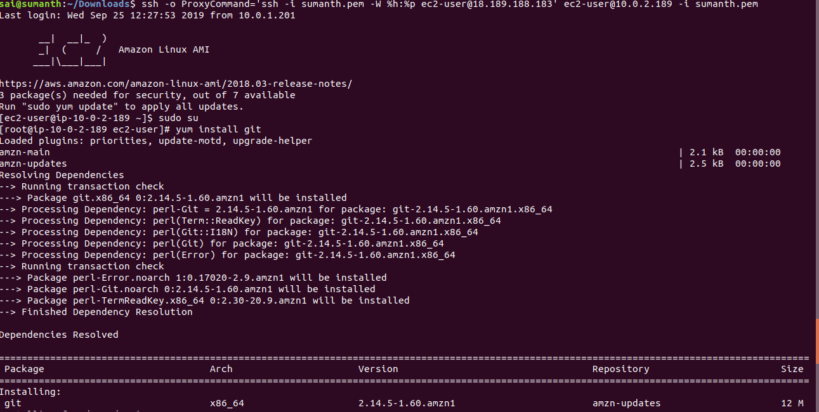

### **Amazon ELB in VPC:**

Create a VPC with private and public subnets and add routes to the route table.

Create auto scaling groups which create two public and two private instances and create a load balancer .

While creating autoscale configuration create a new security group and app the vpc you created in security group.

Instances created:

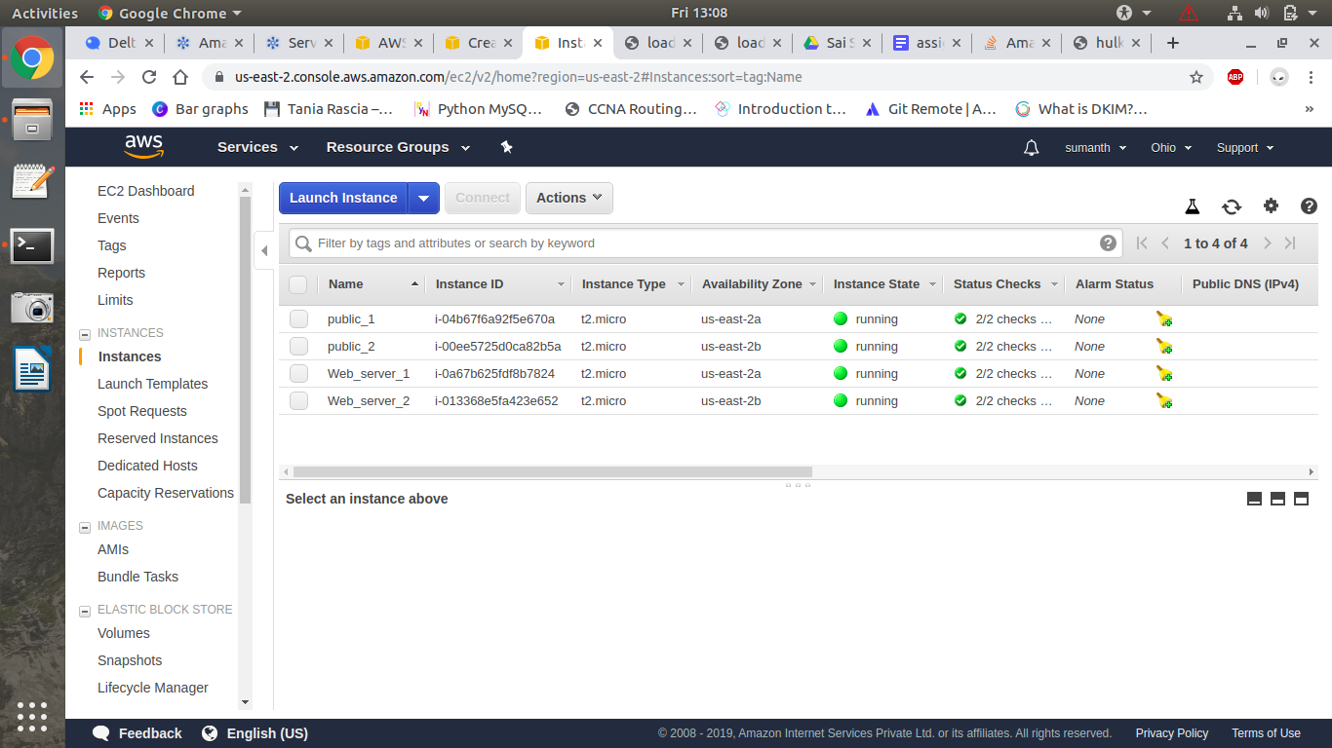

Add public subnets in availability zone:

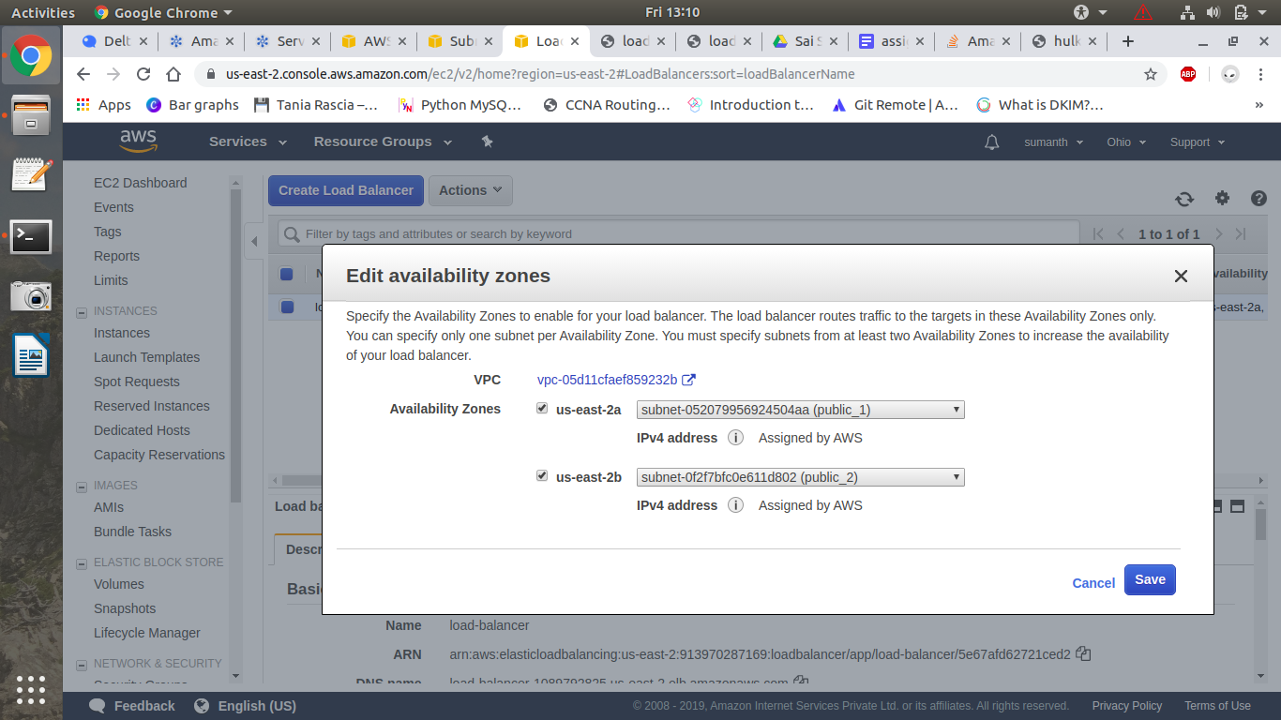

Copy the address of load balancer and first web server will be displayed.

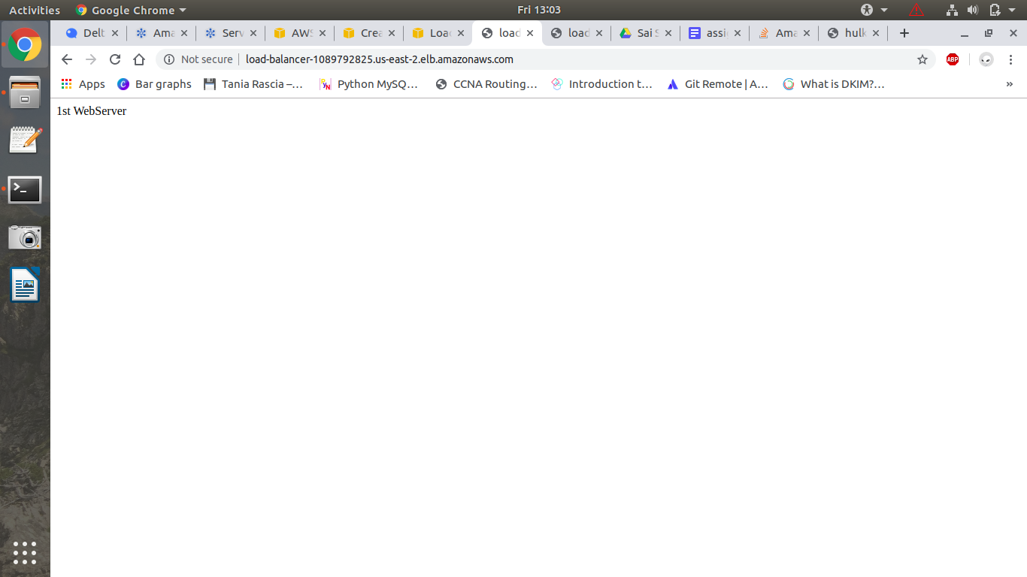

Hit refresh and 2nd web server will be displayed.

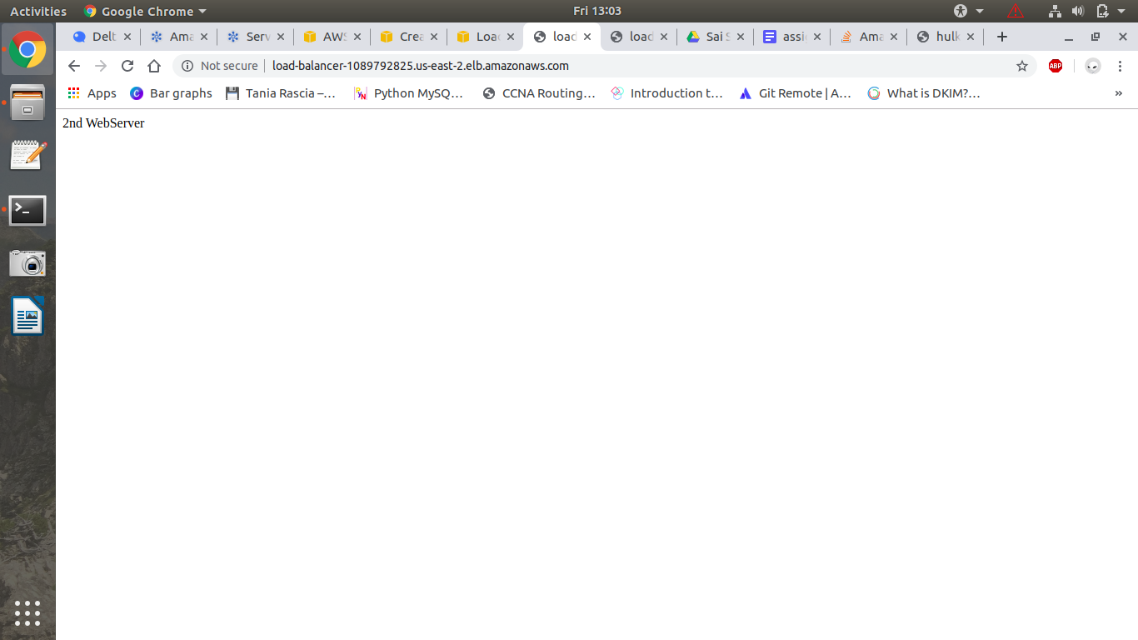

### **CloudFront:**

Create a cloudfront distribution, select web distribution and enter origin name i.e., domain name and origin path if there are any folders and in the default root object place the name of the file you want to display when the cloud front is loaded.

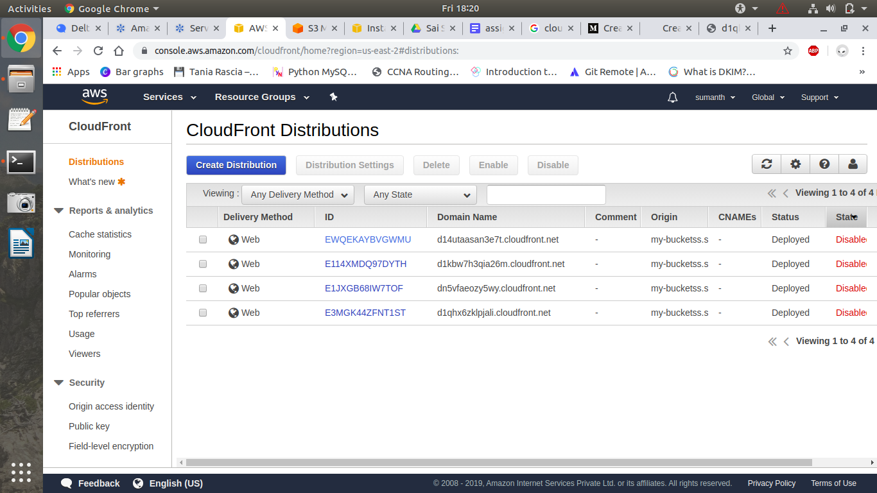

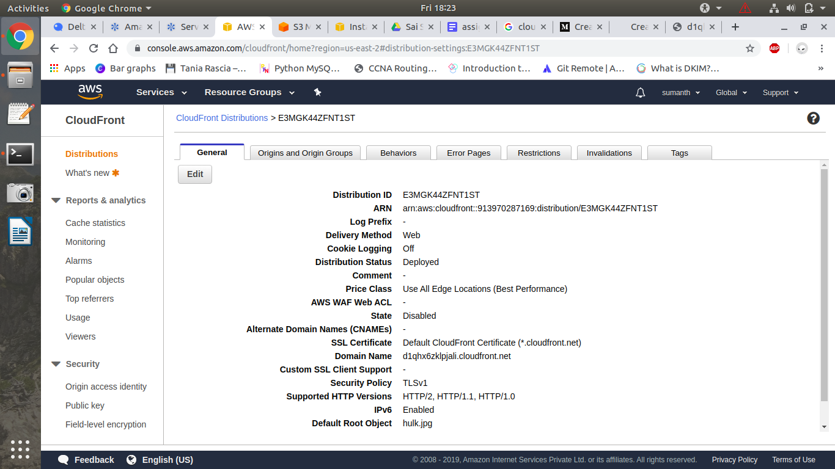

By using cloudfront we can access the file much faster than accessing it through s3 bucket .

But cloudfront will take some time to load for the first user but for the next users it will take much less time than accessing it though s3 bucket.